9th – 12th Graders
MARCH FOR LIFE TRIP TO D.C.
January 14-20, 2018
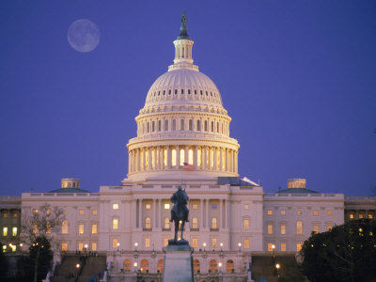
Cost:
ONLY $500 for students and chaperones
(4 monthly payments of $125 each beginning in October)

9th-12th Graders are invited to join us for this great trip to Washington, D.C. on a coach bus with free wi-fi. In addition to participating in the March for Life, we will lay a wreath at the Tomb of the Unknown Soldier at Arlington Cemetery, tour the U.S. Capitol, the National Archives, the Holocaust Museum, Ford’s Theater, visit the Basilica of the National Shrine of the Immaculate Conception, Saint JPII National Shrine, see the White House, and many Memorials. Over 400,000 people, mostly teens and young adults, converge on our nation’s capital each year to bear witness to the sanctity of human life.
________________________________________
If you are in the 9th-12th grade, and would like to join us, please contact
Jackie Gow #701-232-2414 or email jackieg@nativitycatholicchurch.net
March for Life Trip to Washington, D.C. Registration Form
Return this form to Jackie Gow in the parish office and $125 no later than October 18 to reserve your spot.
Student Full Name _________________________________________ Birthday ____________
Home Phone _____________________ (Cell or other) _________________
Mailing Address ________________________________City ___________________
State _______ Zip code _______________ Email ___________________________________________
School ___________________________________Grade in 2017-2018 _____________
Parent's / Guardian Name ________________________________________
Parent/Guardian Mailing Address _________________________________(if different than the student)
Parent/Guardian Email Address ______________________________________
The following are special circumstances regarding the student that you should be aware of: ________________________________________________________________________________________________________________________________________________
If under 18 the parents/guardian must read and sign this form.
I give permission for my son/daughter to take part in the Holy Cross/Sts. Anne & Joachim / Nativity Catholic Church Trip to Washington, D.C. We understand that if it is deemed necessary by the group leader to send my son/daughter home early for breaking the Contract of Behavior, we will be liable for the expenses incurred. We the undersigned have read this release and understand all its terms and execute it voluntarily and with full knowledge of its significance.
Signature of parent or guardian ____________________________ Date _____________
All pilgrims must read and sign this portion.
I agree that while attending the event, I will participate in all activities and events scheduled. I will also follow the directions of those in charge, especially my chaperone and will treat them and our hosts with respect. If I choose to break the Contract of Behavior, I understand that I will be liable to a loss of individual freedom during the remainder of the trip and may be sent home at my own and my family's expense.
Participant signature ___________________________________ Date ______________

