ANDES SKI TRIP
Grades 6-12
Monday February 19, 2018
(Presidents’ Day)

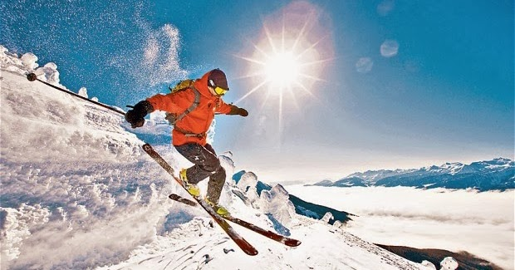
BUS LEAVES 8:00 A.M.
BUS RETURNS 8:00 P.M.
Buses leave & return to Sts. Anne & Joachim

REGISTRAION DEADLINE…
Wednesday, January 16!
BUS LEAVES 8:00 A.M.
BUS RETURNS 8:00 P.M.
Buses leave & return to Sts. Anne & Joachim

REGISTRAION DEADLINE…
Wednesday, January 16!
BUS LEAVES 8:00 A.M.
BUS RETURNS 8:00 P.M.
Buses leave & return to Sts. Anne & Joachim

REGISTRAION DEADLINE…
Wednesday, January 16!

Cost: $55
Includes Lift Ticket, Ski Rental & Transportation
∗ Snowboard & Helmet Rental: Extra $18
∗ Cost: $36 if you have your own ski equipment
(Helmets Required for ALL Snowboarders!)

BUS LEAVES NATIVITY 8:00 A.M.
BUS RETURNS TO NATIVITY 8:00 P.M.

REGISTRAION DEADLINE
Monday, February12

Liability Release Form
RELEASE OF ALL CLAIMS
The undersigned do hereby release, forever discharge and agree to hold harmless Holy Spirit,
Nativity, Sts. Anne & Joachim, St. Anthony’s, and St. Joseph’s Catholic Churches from and
against any and all liability, claims, demands, lawsuits and expenses of any kind arising from
personal injury, sickness, death, or property damage of any kind whatsoever which may be
incurred or suffered by the undersigned and/or participant (if participant is under 18,18 or older).
The undersigned further agree to indemnify Holy Spirit, Nativity, Sts. Anne & Joachim, St.
Anthony’s, and St. Joseph’s Catholic Churches and its respective members, directors, employees, and agents (collectively, the “indemnities”,) harmless and against any and all claims, demands, actions, lawsuits, and liabilities, including attorney fees and expenses sustained by the Indemnities as the result of negligent, willful or intentional acts of the undersigned and/or participant (if participant is under 18, 18 or older).
If participant is under 18 years of age, I (we) the parent(s) or legal guardian(s) of the participant,
do hereby grant permission for our child to participate fully in the Ski Trip and hereby give
permission to Holy Spirit, Nativity, Sts. Anne & Joachim, St. Anthony’s, and St. Joseph’s
Catholic Churches to take said participant to doctor or hospital and hereby authorize medical
treatment, including but not limited to emergency surgery and I (we) fully and completely assume all responsibility for all medical bills.
Further, should it be necessary for the participant to return home due to medical reasons,
disciplinary action or otherwise, I (we) assume all responsibility and transportation costs.
The form below MUST be completed for every participant. If participant is under 18,
parent or legal guardian must sign.
Participant’s Name (Please Print) ___________________________________________
Do you want a FREE ski lesson when you arrive? __________YES _________NO
Mailing Address ____________________________________________________________
Contact Email: ______________________ Cell # _______________ Wk #__________
Parent/Legal Guardian’s Name (Please Print) ________________________________________
Parent’s/Legal Guardian Signature_____________________________ Date_______________
Current Medications_____________________________________________________________
Allergies or Other Medical Concerns_______________________________________________
Insurance Company____________________________ Policy#_________________________

Complete this form and return to Parish Office with payment by Monday, February 12

